Jal Rekha

High Level Design (HLD)



Madhya Pradesh State Electronics Development Cooperation State IT Centre, 47-A, Arera Hills, Bhopal
https://mpsedc.mp.gov.in/

High Level Design (HLD)
Jal Rekha Project – FHTC Module(Functional Household Tap Connection)
Target Users: Field Engineers (FE), Supervisory & Backend Systems

Organization: Madhya Pradesh State Electronics Development Corporation (MPSEDC)
Client: MP Jal Nigam Maryadit
Document Type: High Level Design Document

1. Purpose of the Document
This High Level Design (HLD) document provides an architectural and functional overview of the FHTC (Functional Household Tap Connection) Module of the Jal Rekha mobile application. It describes the system components, user roles, core workflows, integrations, and non-functional requirements without going into implementation-level details.

2. Business Objective
The FHTC module aims to:
- Digitize household tap connection surveys under Jal Jeevan Mission
- Enable geo-tagged, photo-verified tap installation reporting
- Support offline-first field operations in rural areas
- Ensure transparency, auditability, and data accuracy

3. Stakeholders
- Field Engineer (FE): Performs household survey and tap verification using mobile app
- Government Officials / GM: Review, approve, or reject submitted connections
- System Administrators: Maintain backend services and infrastructure

4. System Overview
The FHTC module is a mobile-assisted, backend-governed system consisting of:
- An Android mobile application for field data capture
- Backend web services for validation, storage, and reporting
- Centralized servers for authentication, data processing, and monitoring
The system follows an offline-first architecture to ensure uninterrupted field operations.

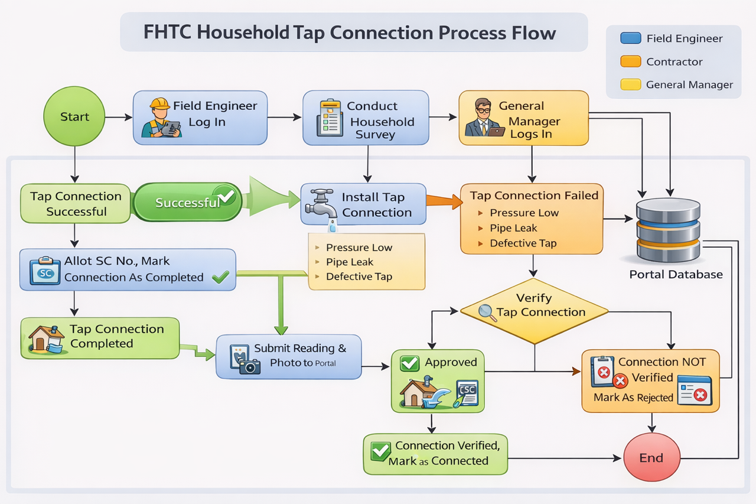
5. High Level Architecture

5.1 Architecture Style
- Client–Server Architecture
- Offline-First Mobile Design
- REST-based Integration

5.2 Major Components
- Mobile Application (Android)
  - User Authentication
  - Offline Data Capture & Draft Management
  - GPS & Camera Integration
  - Data Synchronization
- Backend Services
  - RESTful APIs (WCF / .NET)
  - Authentication & Authorization
  - Business Rule Validation
- Data Storage
  - Local SQLite Database (Mobile)
  - Centralized Relational Database (Server)
- External Services
  - Google Maps API (GPS & Reverse Geocoding)

6. Technology Stack (High Level)
Layer | Technology
Mobile | Android (Java / Kotlin)
Backend | .NET WCF REST Services
Security | JWT Token-based Authentication
Local Storage | SQLite
Mapping | Google Maps API
Hosting | IIS on In-House Cloud

7. User Roles & Access

7.1 Field Engineer (FE)
- Login to mobile application
- Download assigned village & household data
- Conduct household survey
- Capture GPS location and photos
- Submit or sync data

7.2 Supervisory Users (Web)
- Review submitted surveys
- Approve or reject connections
- Provide rejection remarks for rework

8. Functional Overview

8.1 Dashboard
The dashboard acts as the central control panel for Field Engineers, providing access to:
- Data Download for offline use
- Household Survey / HSC Verification
- Offline Data Synchronization
- Draft Management
- Submission History

8.2 Household Identification
- Selection based on administrative hierarchy:
  - Scheme → District → Block → GP → Village
- Search using:
  - Beneficiary Name
  - Mobile Number
  - Family ID / Member ID
- Duplicate prevention using Samagra Family ID

8.3 Tap Installation & Verification
Key verification elements:
- GPS capture with geo-fencing (within 50 meters)
- Mandatory photographic evidence
- Installation details:
  - Location (Inside / Outside Premise)
  - Status (Accepted / Rejected)
  - Quality checks (Pressure, Leakage, Defects)

9. High Level Workflows

9.1 Survey & Installation Workflow
- FE logs into the mobile app
- Downloads assigned household data
- Selects beneficiary household
- Captures survey, GPS, and photos
- Installs tap connection
- Submits data (online) or saves as draft (offline)

9.2 Offline Data Workflow
- Data stored locally when network is unavailable
- Records marked as Draft
- Manual synchronization when connectivity is restored
- Secure upload using JWT-authenticated APIs

9.3 Rejection & Re-submission Flow
- Rejected connections are returned with remarks
- FE updates issues (e.g., leak, low pressure)
- Corrected data is re-submitted for approval

10. Security Overview
- JWT-based authentication for all API calls
- Role-Based Access Control (RBAC)
- Secure communication over HTTPS
- Geo-location and photo validation to prevent misuse

11. Error Handling & Validations (High Level)
- Submission blocked if GPS data is unavailable
- Mandatory validation of survey fields and photos
- Graceful handling of network failures
- Retry mechanism via offline sync

12. Non-Functional Requirements
- Availability: Must function without internet
- Performance: Fast local data access
- Scalability: Supports large rural datasets
- Reliability: No data loss during sync
- Usability: Simple UI for field engineers

13. Assumptions & Constraints
- GPS accuracy depends on device capability
- Internet availability is intermittent in rural areas
- Android devices are government-approved

14. Conclusion
The FHTC module is designed as a robust, offline-capable mobile solution that ensures transparent, accurate, and verifiable reporting of household tap connections. The high-level architecture supports scalability, security, and operational reliability aligned with the objectives of the Jal Jeevan Mission.

